Software Release Report- Consumer Care

|  |  |  |  |  |
| --- | --- | --- | --- | --- |
| **Document History** | | | | |
| **Version** | **Date** | **Author** | **Section** | **Changes** |
| 1.0 | 25-07-2015 | Deepthi Shivakumar | All | Release version 2.0.0 |
| 1.1 | 10-08-2015 | Deepthi Shivakumar | All | Removed privacy policy notes section.  Included 2.0.1 changes. |
| 1.2 | 30-09-2015 | Deepthi Shivakumar | All | Included 2.1.0 changes for bazaar voice |
| 1.3 | 01-12-2015 | Deepthi Shivakumar | All | Modifications for PI 15.2 release( version 3.0.0 ) |
| 1.4 | 01-03-2016 | Deepthi Shivakumar | All | Modifications for PI 16.1 release ( version 4.0.2 ) |
| 1.5 | 13-05-2016 | Sameer Sulaiman | All | Modifications for PI 16.2 release ( version 4.2.0 ) |
| 1.6 | 22-07-2016 | Sameer Sulaiman | All | Modifications for PI 16.3 release ( version 5.0.0 ) |
| 1.7 | 08-09-2016 | Sameer Sulaiman | Specific 6.0.0 changes & version updates | Modifications for PI 16.4 release ( version 6.0.0 ) |
| 1.8 | 01-12-2016 | Sameer Sulaiman | Specific 6.1.0 changes & version updates | Modifications for PI 16.5 release ( version 6.1.0 ) |
| 1.9 | 03-02-2017 | Sameer Sulaiman, Niharika Bundela | Specific 7.0.0 changes & version updates | Modifications for PI 17.1 release ( version 7.0.0 ) |

|  |  |  |  |
| --- | --- | --- | --- |
| Administrative Information | | | |
| Project Name | Horizontal (Consumer Care) | Project Identification | NA |
| Project Leader | Sumant Bhargav | Date | 01-March-2016 |
| Quality Leader | Sudhir | Form Filled by | Deepthi Shivakumar |
| Name  Address  Phone  Fax | All Projects in CDP | | |

|  |  |
| --- | --- |
| **Authorisation** | |
| Quality Leader Signature | Project Leader Signature |
| Sudhir | Sreenath Kooloth |

**For Code:**

**Product : Consumer Care**

**Release Version :** **7.0.0**

**Release Date: 09- February -2017**

Integration document: Refer DigitalCare_PI17.1_V7.0.0_Integration_IOS.pdf

Customer Version ID (Optional): NA

# **Release Description:**

# Digital care is a horizontal library project developed both on Android and IOS platform. It offers common functionalities related to consumer care which can be used in all Philips applications.

Version number of this release is 7.0.0

# **Source code Links:**

https://(code1 id)@bitbucket.atlas.philips.com/scm/cc/consumer_care_ios.git

**Branch: PI17.1**

# **Source/Binary Files Description:**

# Not applicable

# **System Requirements / Configuration:**

IOS version: IOS 8 and above.

**Specific 7.0.0 Changes:**

* Integrated PUIToolKit. Replaced the Config File Theme settings with PUIToolKit integration for UIControls.
* Integrated Service Discovery, base URLs are coming from service discovery.
* Live Chat URL API integration, (which will help china to configure their chat url as well based on country).
* Baidu Map support for china.
* Config file changes for menu can be done based on the country, Language, version etc.

# **Supported features:**

* **Tell us what you think:** This has both app review which redirects to play store and product review.
* **Contact us :** It has following sub features   
        a. Live chat : It redirects to website where user can chat with customer

Care executive related to the product.

b. Send email: User can send an email related to the product.  
      c. Call us: It displays customer care number which is product and locale specific.

c. Tweet: User also can tweet to Philips Twitter page of specific product.

d. Post: User can post to public Philips Facebook page.

* **Find Philips near you:** It displays nearest Philips service centres which is rendered on Google map. Latitude and longitude values are based on sub category of product.
* **FAQs:** User can view product specific FAQs which is also localized.
* **Register my product:** User will be able to register the product after he/she registers user details with Philips. It is developed as a separate library which needs to be invoked by application.
* **View product information:** In this feature, user can view product information like product title, product image, product manual, product videos and more information on website.

This is available for single product. Also vertical apps can add customized button inside this menu which is related to a product as per the requirement.

* Localization support for all languages supported by Philips is added.
* Provides flexible architecture to add vertical specific buttons.

**Known Issues:**

* Live chat supports only chinese for china and English for other countries.

**Localization support**

|  |  |  |  |  |  |
| --- | --- | --- | --- | --- | --- |
| English | German | French (FR) | Simplified Chinese | Traditional Chinese | Portuguese (EU) |
| Russian | Arabic | Japanese | Dutch | Malay | Montenegrin |
| French-CA | Romanian | Spanish Mexican | Ukrainian | Portuguese (BR) | Serbian |
| Gaelic | Greek | Hebrew | Hindi | Finnish | Swedish |
| Italian | Polish | Spanish | Korean | Czech | English UK |
| Norwegian | Albanian | Bosnian | Bulgarian | Croatian | Estonian |
| Hungarian | Indonesian | Kazakh | Latvian | Lithuanian | Macedonian |
| Slovak | Slovenian | Spanish (AR) | Thai | Vietnamese | Danish |
| Farsi | Turkish |  |  |  |  |

**Notes**

* Please refer integration document and sample app for complete details.
* If app supports more than 10 products, current approach of providing product list passed/configured by vertical (support more than 10 not available ), Please contact the team for further assistance.
* Each business needs to upload all product data to PRX and please find data upload process ppt attached.
* Consumer care component consumes PRX data for most of the features. From **iOS** **9** onward’s APPTransportSecuritySettings is blocking **NONHTTP** urls. We already raised request for converting all the PRX response url’s to **HTTPS**. Till they fix it all the integrating app’s has to whitelist the http domain’s or AllowArbitrayLoads in their app info.plist for the PRX response data. For security reason few apps are not allowing AllowArbitrayLoads for all url’s. Mentioned below most of the domains we found from PRX response that integrating app can whitelist in their app info.plist.

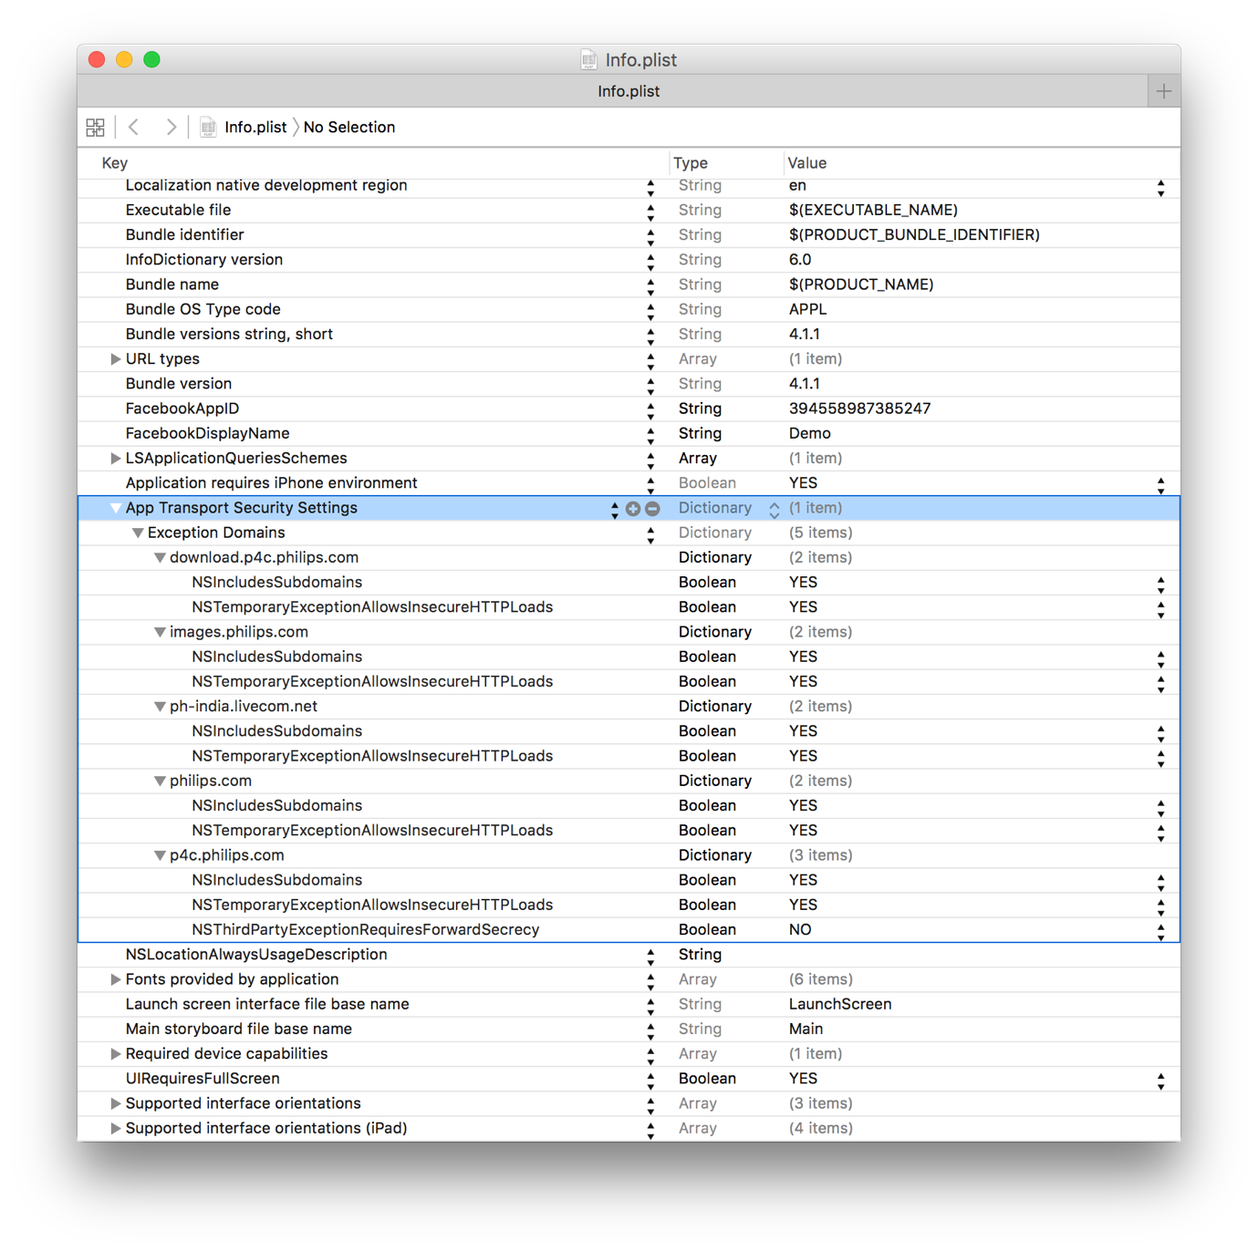

**@All** if we missed any **PRX** http url response domain apart from the above mentioned , please whitelist it in your respective app info.plist.

